Experiment 6
SELECT with various clause – BETWEEN, IN, Aggregate function
AIM:
To view the records from the tables using SELECT commands with BETWEEN, IN, Aggregate functions.
DESCRIPTION:
➢ The BETWEEN operator allows you to specify a range to test. We often use the BETWEEN operator
in the WHERE clause of the SELECT, INSERT, UPDATE, and DELETE statements.
➢ The IN operator allows you to determine if a specified value matches any one of a list or a sub query.
➢ MySQL provides many aggregate functions that include AVG, COUNT, SUM, MIN, MAX, etc. An
aggregate function ignores NULL values when it performs calculation except for the COUNT function.
BETWEEN operator:
SELECTcolumn1,column2,...
FROMtable_name
WHERE expr [NOT] BETWEEN begin_expr AND end_expr;

The expr is the expression to test in the range that is defined by begin_expr and end_expr.
IN operator:
SELECTcolumn1,column2,...
FROMtable_name
WHERE (expr|column_1) IN ('value1','value2',...);

Questions:
IN & BETWEEN
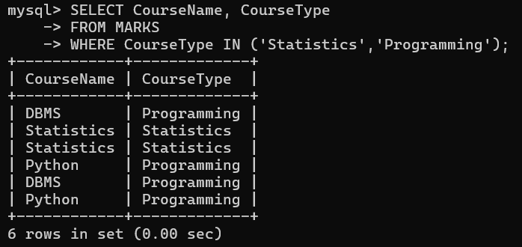
1. List the type of the courses “Statistics” and “Programming”
2. The instructor wants to know the CourseNos whose scores are in the range 50 to 80
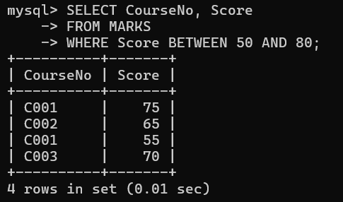

AGGREGATE
1. Find the average mark of “C002”.
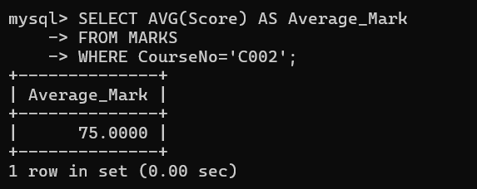
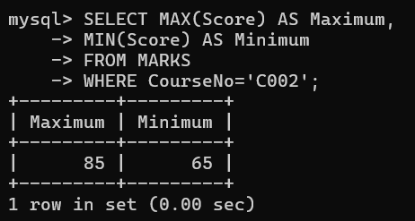
2. List the maximum, minimum mark for “C002”

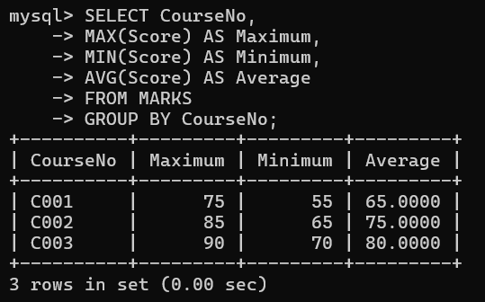
3. List the maximum, minimum, average mark for each course

4. List the name of the courses and average mark of each course.
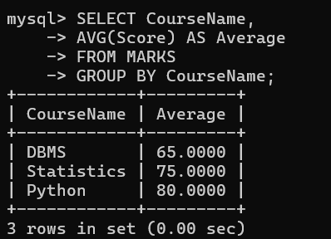

5. Calculate the sum of all the scores.
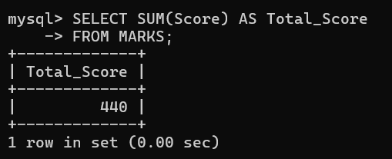
6. How many students are registered for each course? Display the course description and the number of students registered in each course.
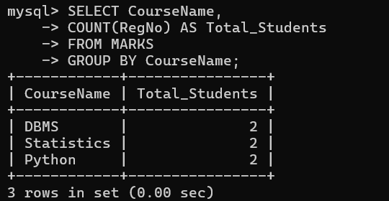

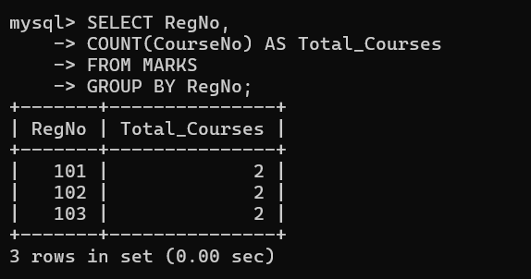
7. How many courses did each student register for?

